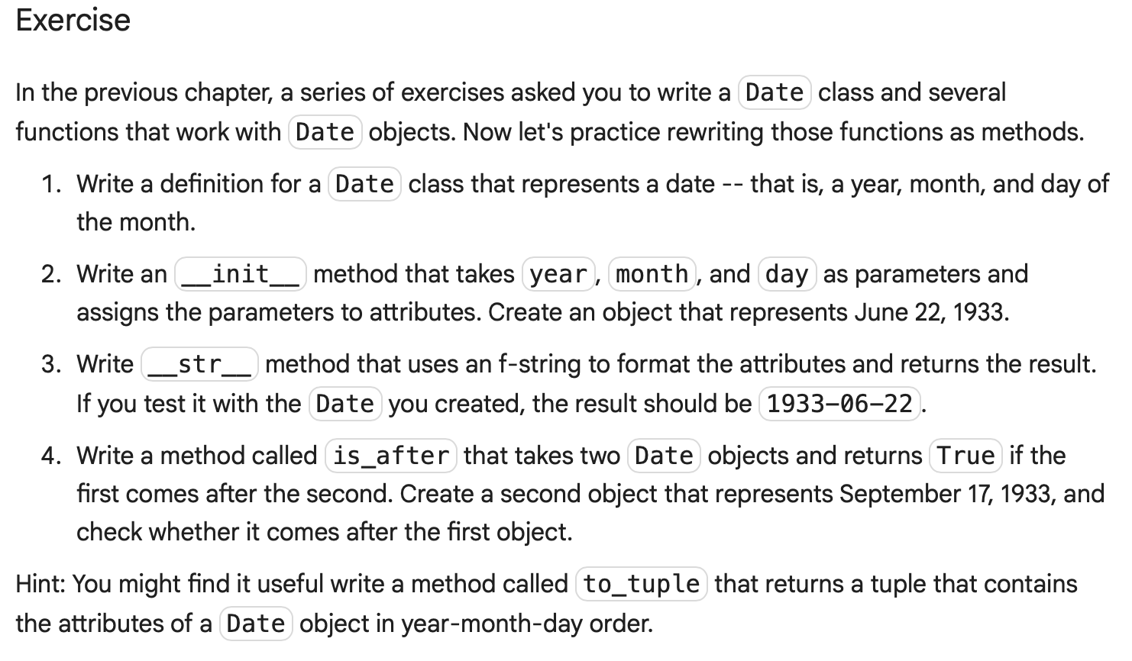
Unit 1

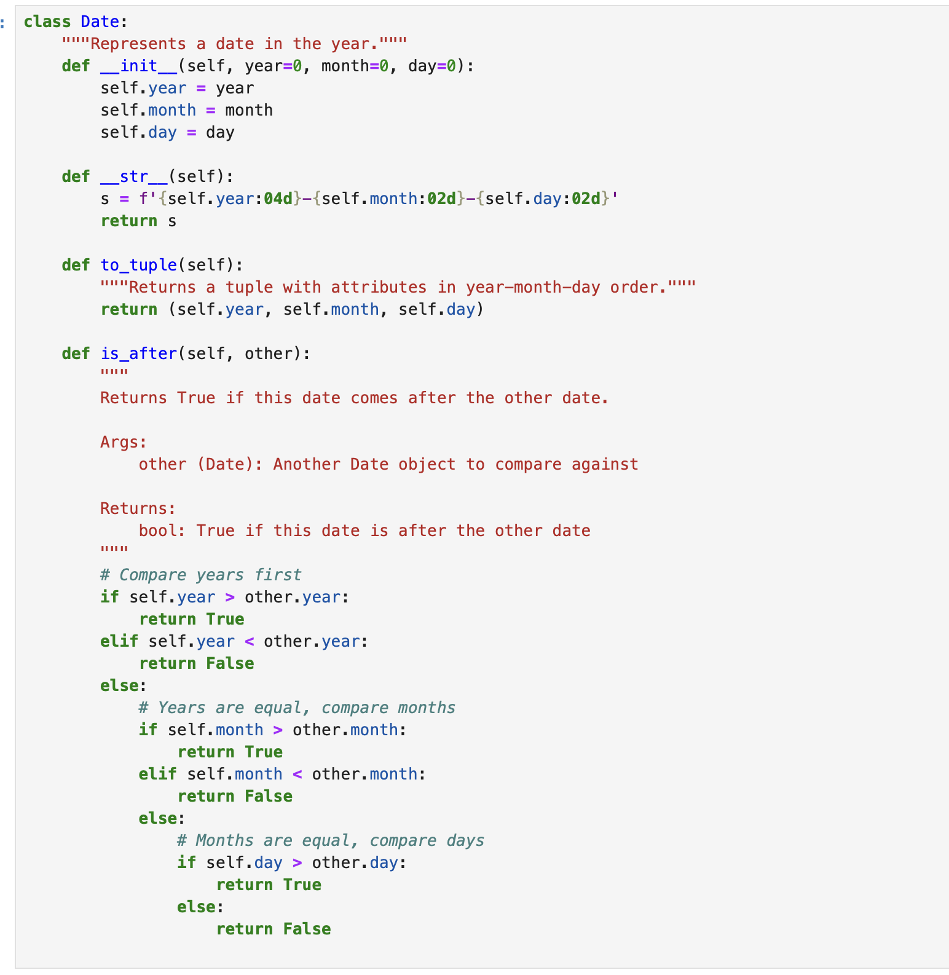

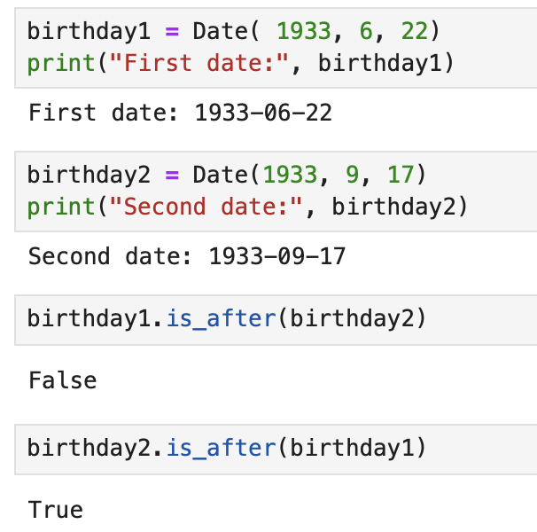

Unit 2

Exercise
Write an __eq__ method for the Line class that returns True if the Line objects refer to Point objects that are equivalent, in either order.

Exercise
Write a Line method called midpoint that computes the midpoint of a line segment and returns the result as a Point object.

Exercise
Write a Rectangle method called midpoint that finds the point in the center of a rectangle and returns the result as a Point object.

Exercise
Write a Rectangle method called make_cross that does the following:
- Uses make_lines to get a list of Line objects that represent the four sides of the rectangle.
- Computes the midpoints of the four lines.
- Makes and returns a list of two Line objects that represent lines connecting opposite midpoints, forming a cross through the middle of the rectangle.

Exercise
Write a definition for a class named Circle with attributes center and radius, where center is a Point object and radius is a number. Include special methods __init__ and a __str__, and a method called draw that uses jupyturtle functions to draw the circle.

Unit 3

e-Portfolio Activities
Discuss which UML models are most applicable at different stages of the Software Development Life Cycle.
Making reference to ‘The Unified Modeling Language Reference Manual Second Edition’, use the State Machine Diagram in Figures 3-7 in Chapter 21 to design a similar model for a washing machine.
You can share your work with your tutor via email for formative feedback.

Unit 4 Seminar

Title: UML Design
Design an activity diagram which shows the relationships and interactivity between the tasks executed by a humanoid robot performing a task of your choice. You can read more about activity diagrams at the Visual Paradigm website.
Expand the activity diagram with the development of a class diagram using UML to support a system with basic employee-related functionality. This should include the retention of employee details and allow an employee to book a day of annual leave.
Develop the Python program to implement the class model.
Record your responses in your e-portfolio.

Can use coursework as example

Unit 5 –
e-Portfolio Activity: Polymorphism
An example of a Python program which uses polymorphism is shown below.

class Cat:
def __init__(self, name, age):
self.name = name
self.age = age

def info(self):
print(f"I am a cat. My name is {self.name}. I am {self.age} years old.")

def make_sound(self):
print("Meow")

class Dog:
def __init__(self, name, age):
self.name = name
self.age = age

def info(self):
print(f"I am a dog. My name is {self.name}. I am {self.age} years old.")

def make_sound(self):
print("Bark")

cat1 = Cat("Kitty", 2.5)
dog1 = Dog("Fluffy", 4)

for animal in (cat1, dog1):
animal.make_sound()
animal.info()
animal.make_sound()

Source: Programiz. (no date) Polymorphism in Python.
Write a Python program with polymorphism that is usable within the summative assessment for the humanoid robot.
2 - Practical Activity – think Python

Exercise
One of the exercises in Chapter 7 asks for a function called uses_none that takes a word and a string of forbidden letters, and returns True if the word does not use any of the letters. Here’s a solution:
def uses_none(word, forbidden):
for letter in word.lower():
if letter in forbidden.lower():
return False
return True

Write a version of this function that uses setoperations instead of a for loop. Hint: ask a virtual assistant “How do I compute the intersection of Python sets?”

Exercise
Scrabble is a board game where the objective is to use letter tiles to spell words. For example, if we have tiles with the letters T, A, B, L, E, we can spell BELT and LATE using a subset of the tiles—but we can’t spell BEET because we don’t have two Es.
Write a function that takes a string of letters and a word, and checks whether the letters can spell the word, taking into account how many times each letter appears.

Exercise
In one of the exercises from Chapter 17, my solution to has_straightflush uses the following method, which partitions a PokerHandinto a list of four hands, where each hand contains cards of the same suit:
def partition(self):
"""Make a list of four hands, each containing only one suit."""
hands = []
for i in range(4):
hands.append(PokerHand())

for card in self.cards:
hands[card.suit].add_card(card)

return hands

Write a simplified version of this function using a defaultdict.

Exercise
Here’s the function from Chapter 11 that computes Fibonacci numbers:
def fibonacci(n):
if n == 0:
return 0

if n == 1:
return 1

return fibonacci(n-1) + fibonacci(n-2)

Write a version of this function with a single return statement that uses two conditional expressions, one nested inside the other.

Exercise
The following is a function that recursively computes the binomial coefficient:
def binomial_coeff(n, k):
"""Compute the binomial coefficient "n choose k".

n: number of trials
k: number of successes

returns: int
"""
if k == 0:
return 1

if n == 0:
return 0

return binomial_coeff(n-1, k) + binomial_coeff(n-1, k-1)

Rewrite the body of the function using nested conditional expressions.
This function is not very efficient because it ends up computing the same values over and over. Make it more efficient by memoizing it, as described in “Memos”:
binomial_coeff(10, 4) # should be 210

210

Exercise
Here’s the __str__ method from the Deckclass in “Printing the Deck”:
%%add_method_to Deck

def __str__(self):
res = []
for card in self.cards:
res.append(str(card))
return '\n'.join(res)

Write a more concise version of this method with a list comprehension or generator expression.

Unit 6

Pratical Activity – Encapsulation – think python

Unit 6 Seminar

Title: Abstraction in Object Oriented Programming
Discuss the metrics used to assess the features of an object-oriented program.
Develop a Python program which has three abstract methods and one subclass which allows a user to perform banking operations.
Read the article byYu, S and Hou, X (2023) and respond to the following:
- What is agent-based modelling?
- Conduct further research and compare component-based modelling and agent-based modelling.
- Discuss the application of agent-based modelling in the context of the work presented in this paper.
Remember to also record your responses in your e-portfolio.

Unit 7 –
e-Portfolio Activities| 5 hrs
You can complete one or more of the following activities for inclusion in your e-portfolio.
- Discuss the ways in which data structures support object-oriented development. Use examples of three different data structures to contextualise your response.
- Create a nested dictionary of data on cars within a Car class. Extend the program to work with the dictionary by calling the following methods:
  - items()
  - keys()
  - values()
- Read the article by Y A Zagorulko et al (2021). Develop a program which allows a user to enter the properties which they require of a design pattern, and have the program make a recommendation. Your program should use a constructor to initialise attributes and assign values to variables based on input entered by the user.

Unit 8 –

collaborative post Discussion Topic: OO Design for IoT
Referring to the article by Baskara et al (2024) consider the strengths and weaknesses of designing a metamodel to support object-oriented design of the IOT. Design a smart model equivalent to Figure 1 or Figure 2 which would instead support operation of a humanoid robot.
Practical Activity - Recursion and Polymorphism

Exercise
In contract bridge, a “trick” is a round of play in which each of four players plays one card. To represent those cards, we’ll define a class that inherits from Deck:
class Trick(Deck):
"""Represents a trick in contract bridge."""

As an example, consider this trick, where the first player leads with the 3 of Diamonds, which means that Diamonds are the “led suit.” The second and third players “follow suit,” which means they play a card with the led suit. The fourth player plays a card of a different suit, which means they cannot win the trick. So the winner of this trick is the third player, because they played the highest card in the led suit:
cards = [Card(1, 3),
Card(1, 10),
Card(1, 12),
Card(2, 13)]
trick = Trick(cards)
print(trick)

3 of Diamonds
10 of Diamonds
Queen of Diamonds
King of Hearts

Write a Trick method called find_winnerthat loops through the cards in the Trick and returns the index of the card that wins. In the previous example, the index of the winning card is 2.

Exercise
The next few exercises ask to you write functions that classify poker hands. If you are not familiar with poker, I’ll explain what you need to know. We’ll use the following class to represent poker hands:
class PokerHand(Hand):
"""Represents a poker hand."""

def get_suit_counts(self):
counter = {}
for card in self.cards:
key = card.suit
counter[key] = counter.get(key, 0) + 1
return counter

def get_rank_counts(self):
counter = {}
for card in self.cards:
key = card.rank
counter[key] = counter.get(key, 0) + 1
return counter

PokerHand provides two methods that will help with the exercises:
get_suit_counts
Loops through the cards in the PokerHand, counts the number of cards in each suit, and returns a dictionary that maps from each suit code to the number of times it appears.
get_rank_counts
Does the same thing with the ranks of the cards, returning a dictionary that maps from each rank code to the number of times it appears.
All of the exercises that follow can be done using only the Python features we have learned so far, but some of them are more difficult than most of the previous exercises. I encourage you to ask a virtual assistant for help.
For problems like this, it often works well to ask for general advice about strategies and algorithms. Then you can either write the code yourself or ask for code. If you ask for code, you might want to provide the relevant class definitions as part of the prompt.
As a first exercise, we’ll write a method called has_flush that checks whether a hand has a “flush”—that is, whether it contains at least five cards of the same suit.
In most varieties of poker, a hand contains either five or seven cards, but there are some exotic variations where a hand contains other numbers of cards. But regardless of how many cards there are in a hand, the only ones that count are the five that make the best hand.

Exercise
Write a method called has_straight that checks whether a hand contains a straight, which is a set of five cards with consecutive ranks. For example, if a hand contains ranks 5, 6, 7, 8, and 9, it contains a straight.
An Ace can come before a 2 or after a King, so Ace, 2, 3, 4, 5 is a straight and so is 10, Jack, Queen, King, Ace. But a straight cannot “wrap around,” so King, Ace, 2, 3, 4 is not a straight.

Exercise
A hand has a straight flush if it contains a set of five cards that are both a straight and a flush—that is, five cards of the same suit with consecutive ranks. Write a PokerHand method that checks whether a hand has a straight flush.

Exercise
A poker hand has a pair if it contains two or more cards with the same rank. Write a PokerHand method that checks whether a hand contains a pair.

Exercise
A hand has a full house if it contains three cards of one rank and two cards of another rank. Write a PokerHand method that checks whether a hand has a full house.

Exercise
This exercise is a cautionary tale about a common error that can be difficult to debug. Consider the following class definition:
class Kangaroo:
"""A Kangaroo is a marsupial."""

def __init__(self, name, contents=[]):
"""Initialize the pouch contents.

name: string
contents: initial pouch contents.
"""
self.name = name
self.contents = contents

def __str__(self):
"""Return a string representation of this Kangaroo.
"""
t = [ self.name + ' has pouch contents:' ]
for obj in self.contents:
s = ' ' + object.__str__(obj)
t.append(s)
return '\n'.join(t)

def put_in_pouch(self, item):
"""Adds a new item to the pouch contents.

item: object to be added
"""
self.contents.append(item)

__init__ takes two parameters: name is required, but contents is optional—if it’s not provided, the default value is an empty list. __str__ returns a string representation of the object that includes the name and the contents of the pouch. put_in_pouch takes any object and appends it to contents.
Now let’s see how this class works. We’ll create two Kangaroo objects with the names 'Kanga' and 'Roo':
kanga = Kangaroo('Kanga')
roo = Kangaroo('Roo')

To Kanga’s pouch we’ll add two strings and Roo:
kanga.put_in_pouch('wallet')
kanga.put_in_pouch('car keys')
kanga.put_in_pouch(roo)

If we print kanga, it seems like everything worked:
print(kanga)

Kanga has pouch contents:
'wallet'
'car keys'
<__main__.Kangaroo object at 0x7f1f4f1a1330>

But what happens if we print roo?
print(roo)

Roo has pouch contents:
'wallet'
'car keys'
<__main__.Kangaroo object at 0x7f1f4f1a1330>

Roo’s pouch contains the same contents as Kanga’s, including a reference to roo!
See if you can figure out what went wrong. Then ask a virtual assistant, “What’s wrong with the following program?” and paste in the definition of Kangaroo.

Unit 8 Seminar

Title: Errors and Data Structures

Activity 1: Errors
Incorporate the following code into a Python program to handle exceptions.

try:
# do something
pass

except ValueError:
# handle ValueError exception
pass

except (TypeError, ZeroDivisionError):
# handle multiple exceptions
# TypeError and ZeroDivisionError
pass

except:
# handle all other exceptions
pass

Source: Programiz (n.d.) Python Exception Handling Using try, except and finally statement.

Activity 2: Data Structures
- Set operations include:
  - Union
  - Intersection
  - Difference
  - Symmetric difference
Explain a use for each of these set operations within the context of your summative assessment.

- Write a Python program to carry out a linear search on a list data structure.

Unit 9 –
You can complete one or more of the following activities for inclusion in your e-portfolio. You can also share your work with your tutor for formative feedback.

Activity 1
How relevant is the cyclomatic complexity in object-oriented systems? Which alternative metrics do you consider to be more reflective of the complexity of a piece of code, in comparison to the number of independent paths through a program? Support your response using reference to the related academic literature.

Activity 2
To what extent is cyclomatic complexity relevant when developing object-oriented code?

Activity 3
What is the cyclomatic complexity of the following piece of code?

public static string IntroducePerson(string name, int age)
{
var response = $"Hi! My name is {name} and I'm {age} years old.";

if (age >= 18)
response += " I'm an adult.";

if (name.Length > 7)
response += " I have a long name.";

return response;
}
Source: Schultz, C. (2021) Cyclomatic Complexity Defined Clearly, With Examples. LinearB.

Activity 4
Extend the following program to test accuracy of operations using the assert statement.

# Python String Operations
str1 = 'Hello'
str2 ='World!'

# using +
print('str1 + str2 = ', str1 + str2)

# using *
print('str1 * 3 =', str1 * 3)

Source: Progamiz. (no date) Python Strings.

Unit 10 Seminar

Title: Packaging and Testing

Activity 1
Run the following code using pylint and identify the errors.

def factorial (x)
if x == 1:
return 1

else:
return (x * factorial(x-1))

num = 3
print("The factorial of", num, "is", factorial(num))
Source: Progamiz. (n.d.) Python Recursion.

Activity 2
In ‘Packaging & Testing’ (unit 9), we examined the use of documentation to support code developments. Add appropriate commenting and documentation for the code below.

def add(x, y):
return x + y
def subtract(x, y):
return x - y
def multiply(x, y):
return x * y
def divide(x, y):
return x / y
print("Select operation.")
print("1.Add")
print("2.Subtract")
print("3.Multiply")
print("4.Divide")
while True:
choice = input("Enter choice(1/2/3/4): ")
if choice in ('1', '2', '3', '4'):
num1 = float(input("Enter first number: "))
num2 = float(input("Enter second number: "))
if choice == '1': print(num1, "+", num2, "=", add(num1, num2))
elif choice == '2': print(num1, "-", num2, "=", subtract(num1, num2))
elif choice == '3': print(num1, "*", num2, "=", multiply(num1, num2))
elif choice == '4': print(num1, "/", num2, "=", divide(num1, num2))
break the while loop if answer is no next_calculation = input("Let's do next calculation? (yes/no): ")
if next_calculation == "no":
break
else: print("Invalid Input")
Source: Progamiz. (n.d.) Python Program to Make a Simple Calculator.

Activity 3
Read the article by Rani et al. (2021). What impact does this article have on the way in which you have commented the code in the task above?

Activity 4
Integrate unit tests into the code in Activity 2 to test operation of the methods.

Unit 12 Seminar

Title: Design Patterns in a Python Program
Define the test cases for the following system development: Oracle. (n.d.) Cruise Ship Management and Cruise Software.
Which design patterns do you consider to be compatible with others, and why?

